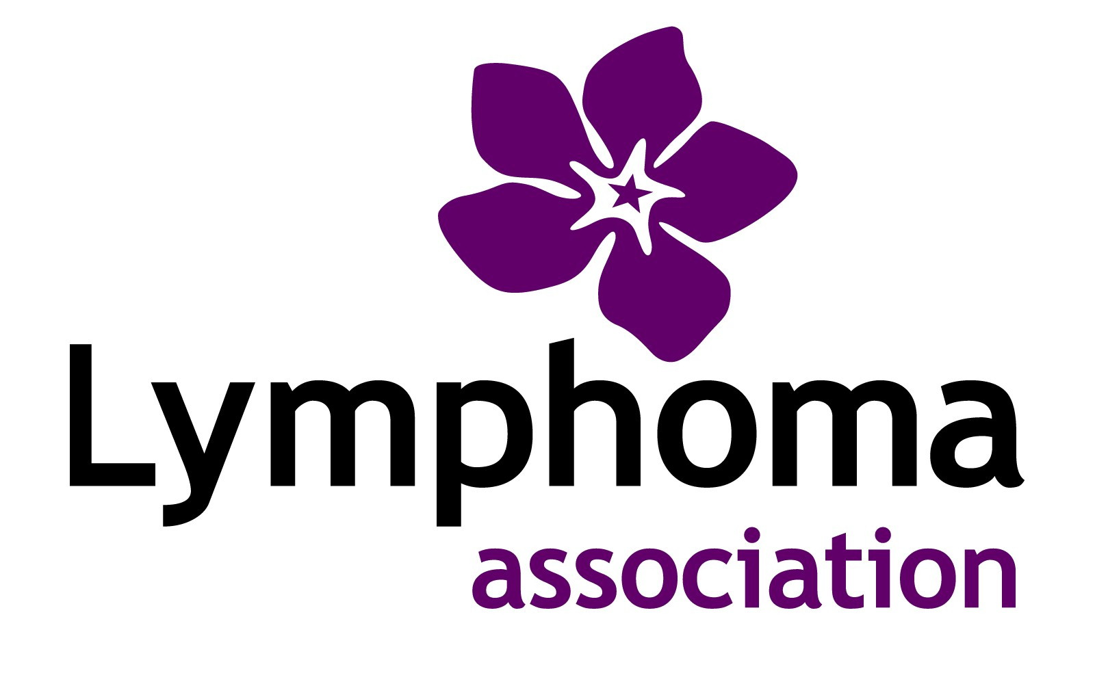

Job Description: Honorary Trustee

The Charity
The Lymphoma Association provides emotional support and information to patients with any form of lymphatic cancer, their families, carers and friends.

The Position
As a trustee you are a member of the Lymphoma Association’s Executive Committee (EC) and a Director of the board of the company – a charity trustee within the meaning of the Charities Act 1993. It is a voluntary position. The EC is responsible for the strategic direction of the charity and for its governance. Day to day management responsibility is delegated to the Chief Executive and the Senior Management Team.

Responsibilities
- To attend regular EC meetings (currently six per year including the AGM)
- To help determine the direction and development of the Lymphoma Association through good governance and strategic planning
- To be available on an occasional ad hoc basis to offer support and expertise to senior staff as appropriate
- To serve as an ambassador for the Lymphoma Association, eg by attendance at occasional internal or external events

- To act in the best interests of the Lymphoma Association and its stakeholders

- To act legally and with integrity at all times, and to operate within the Lymphoma Association’s equal opportunities policy

The Person

Trustees share a vision to improve the situation for those affected by lymphatic cancers.

Skills and expertise of trustees vary and the Lymphoma Association has a policy of recruiting new trustees to fit identified skills gaps. Each trustee contributes according to their own particular field of expertise as well as on a more general basis.

March 2011

